**Exponential equations**

$$\frac{{d(e}^{ax})}{dx}=ae^{ax}$$

**Capacitor**

 $$i=\frac{dq}{dt}=\frac{dcv}{dt}=c\frac{dv}{dt}$$

(Parallel)

(Series)

$$τ=RC$$

$$X_{c}=\frac{1}{2πfC}$$

(Series)

(Parallel)

**Inductor**

$$L=\frac{ʌ}{i}$$

$$v=\frac{dʌ}{dt}=\frac{diL}{dt}=L\frac{di}{dt}$$

(Series)

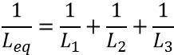 (Parallel)

$$τ=\frac{L}{R}$$

$$X_{L}=2πfL$$

(Series)

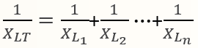(Parallel)

**Impedance and voltage triangle**

>

**Cut-off frequency**

RC filter: $R=X_{C}$

RL filter: $R=X_{L}$

RLC filter: $R=|X_{L}-X_{C}|$

**Resonance frequency**: $X_{L}=X_{C}$

**Theorems of Boolean Algebra**

**Sequential circuits**



